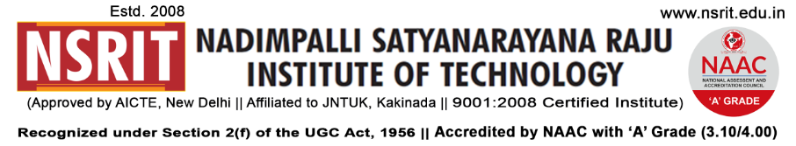
SONTYAM, ANANDAPURAM, Visakhapatnam-531173
NSRIT/CIR/HOD meeting/2018-19/05 Date: 12.07.2018

CIRCULAR

To: HODs of CE/EEE/ME/ECE/CSE/ S&H/MBA/DIPLOMA

It is inform to all the HODs & Staff (Teaching & Non-Teaching) , Mr. B.Srinivasa Rao, Associate Professor, S&H department has been nominated as Chief Transport Officer. All are requested to co-operate.

PRINCIPAL

Copy to:
- Secretary – for kind information
- Correspondent – for kind information
- All HODs – CE/EEE/ME/ECE/CSE/S&H/MBA/Diploma: for information

